EZ Umpire User Manual

Author: Ben Vandenberg

Contents

General 2

Main Menu 2

File Menu 2

View Menu 2

Help Menu 2

Matches 3

Adding a Match 3

Editing a Match 4

Removing a match 4

Umpires 5

Add Umpire 5

Editing an Umpire 6

Removing an Umpire 6

Extra Umpire Features 6

# General

* As of v1.0 the settings menu is a work in progress
* 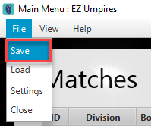The app will automatically load all saved data on launch but will NOT save automatically on close.
  + Can save here

Figure 1

* The save files will be located at C:\Users\%username%\AppData\Roaming\EZ_Umpire

# Main Menu

The main menu is the information hub of the program, here you can interact with the File, View, and Help menus and see all matches in the view period (the period set in the view menu) will display as well as all umpires.

## File Menu

This menu contains basic functions such as Save, Load, Settings, and Close.

## View Menu

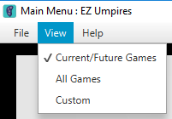The view menu is a very crucial menu and important to understand. It sets the date range that determines what games to show (both in the main menu and umpire dialog), and what games to consider when generating the pay due and notify text.

* The “Current/Future Games” will display all future games and any in the current week.
* The “All Games” displays all games saved
* The “Custom” will bring up a dialog where a custom date range can be entered

## Help Menu

As of now, the only thing here that can be done is open this document

# Matches

## Adding a Match

Adding a match or series of matches is a simple process.

1. In the main menu click “New Game”

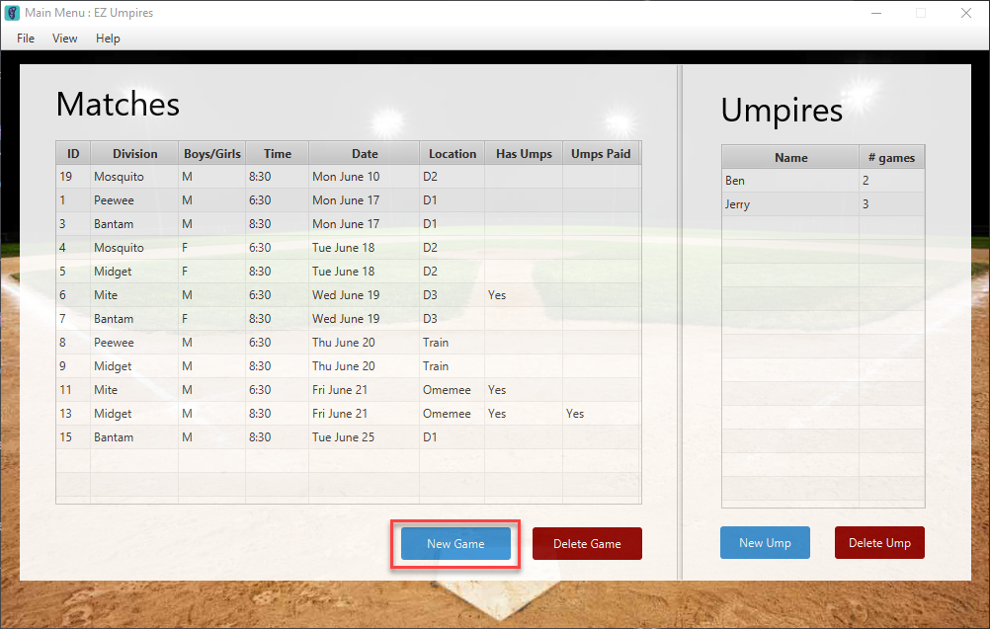

Figure 2

1. Enter information into the New Match dialog (red boxes).
   1. Required info for the game to be saved includes
      1. Division
      2. Location
      3. Date
      4. Time

1. 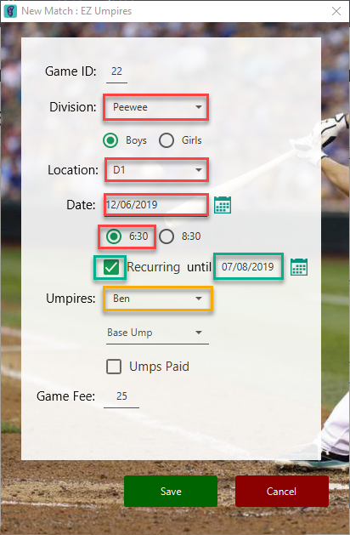(Optional) You can also set the game as recurring. This will create a match with the same details on a weekly basis until the date specified (e.g Figure 3’s match will be a Peewee Boys game that occurs every Wednesday 6:30 from June 12th up until and including Aug. 7th) (green boxes)

1. (Optional) You can also add the umpires while creating the match. The app will only show umpires who are available for that game, this is determined by checking their availability as well as checking if they are already umping another game at the same time. (yellow box)

Figure 3

1. Hit “Save”

Note: The “Game ID” is not able to be changed and is used for identification purposes only. Also, the “Game Fee” is also not editable but will update when the division is updated.

## Editing a Match

To edit a match simply double click on the match in the list in the Main Menu.

## Removing a match

Figure 3

To remove a match, on the main menu click on the match in the list to select it, then double click the “Delete Game” button.

# Umpires

## Add Umpire

1. In the main menu click “New Ump”

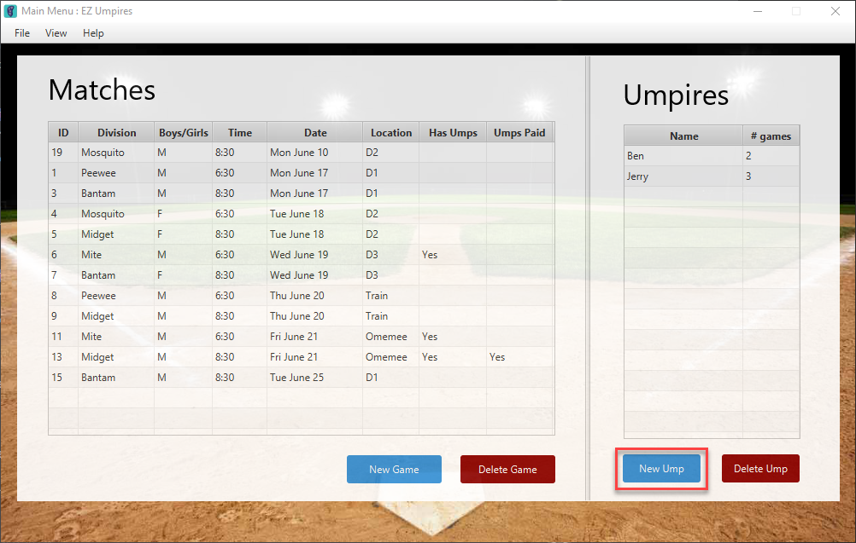

Figure 4

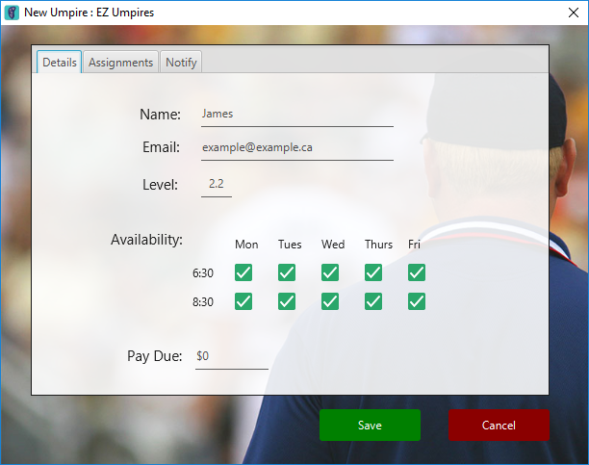

1. Enter information into the New Umpire dialog
   1. Required info for the ump to be saved includes
      1. Name

1. Click “Save”

Note: Level is used to calculate “Pay Due”, If umpire is a level 1.x, then every game fee is $20, otherwise it varies on the game’s division.

Figure 5

## Editing an Umpire

To edit an umpire simply double click on the umpire in the list in the Main Menu.

## Removing an Umpire

To remove an umpire, on the main menu click on the umpire in the list to select it, then double click the “Delete Ump” button.

## Extra Umpire Features

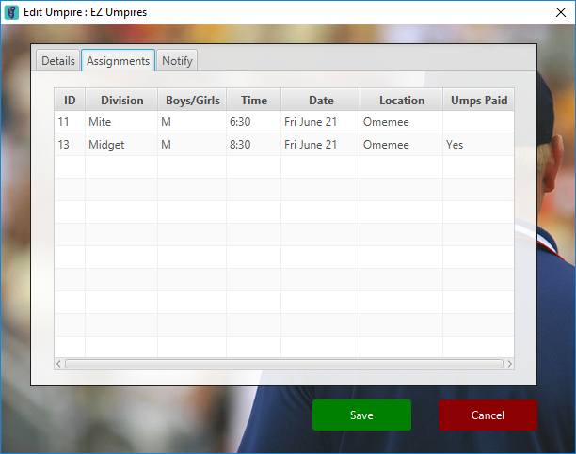

The Umpire Dialog also has some extra features including

* Calculating amount to pay ump. In the umpire dialog on the “Details” tab, the “Pay Due” field will display the amount totaled from all the games they are assigned to in the view period (minus games labelled as “Umps Paid”)
* The Assignments tab (Figure 6) will display all game assignments the umpire has within the view period
* The Notify tab (Figure 7) is used to send schedules out to the umpire given that the email is valid and an there is an internet connection. The text field will display a generated message in accordance to their assignments, this field can be edited to your preference.

Figure 6

* + If the umpire would prefer text messages, it is possible to send emails to phone numbers. The following links can be used to achieve this.
    - 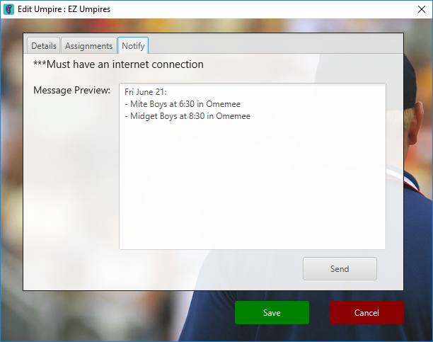<https://freecarrierlookup.com/> - Can be used to find a phone numbers carrier
    - <https://email2sms.info/> - by inputting country and the carrier, site will show the email address

Note: The app will only send an email to the saved email for the ump, this means if the email is changed and without saving an email is sent, it will be sent to the previous email

Figure 7